**JUNERNAL PAPER**

**MINI PROJECT**

**Message Communication Using Android Application**

**Submitted by**

**Name of the Student: M.A.MOHIDEEN ABDUL KHADER**

**Register No:U14IT010**



**Guidance of**

**Mrs.A.RAMA**

**DEPARTMENT OF INFORMATION TECHNOLOGY**

**BHARATH UNIVERSITY (Declared Under Section 3 of UGC Act, 1956) Selaiyur, Chennai -600 073. Tamil Nadu, India.**

**ABSTRACT**

* In this project, Message communication is implemented using android apps between two phones with security. The fundamental problem of key agreement among the parties communicating over an inMessage public network.
* Over the years, a number of solutions to this problem have been proposed with varying degrees of complexity. However, there seems to have been no previous systematic look at the problem of key agreement over combined phone consisting of low-power mobile devices. In present an efficient key agreement scheme is well suited for this networking environment. Our construction is intuitively simple, and yet offers a scalable solution to the problem.

**PROJECT DESCRIPTION**

* In this project a Message communication is achieved between the sender and receiver via Phones messaging process to the message providing Message key agreement.
* Although mobile devices represent an already large and growing percentage of the computing population, security is still a major factor for their full adoption

**EXISTING SYSTEM**

* Sometimes, the confidential information like password, pass code, banking details and private identity to our friends, family members and service providers through an SMS.
* But the traditional SMS service offered by various mobile operators surprisingly does not provide information security of the message being sent over the network.
* In order to protect such confidential information, it is strongly required to provide the service with security.
* End-to-end Message communication between end users.
* SMS usage is threatened with security concerns, such as we present the related work on SMS Spam filtering problem.SMS disclosure, man-in-the-middle attack, replay attack and impersonation attack.
* SMS messages are transmitted as plaintext between mobile user (MS) and the SMS center (SMSC) SMS contents are stored in the systems of network operators and can be read by their personnel.

**PROPOSED SYSTEM**

* Firstly, the solution’s is to provide peer- to-peer SMS security.
* Secondly, in this project, the security services which are provided by the solutions and also it gives attention to five main security services;
* confidentiality,
* integrity,
* authentication and
* Non-repudiation.
* Algebraic cryptanalysis only requires one plain text /cipher text pair .

**MODULES**

* Sender
* Receiver

**MODULE DESCRIPTION**

**SENDER:**

* The next activity is sending message activity if first user enters the particular phone number for who want you sending the confidential message that person phone number.
* Second you enter the message for that person the click the send button that will encrypt the given message from the user then send the message.
* If the message is send the “Message is send” toast is shown otherwise the “Message not delivered”.

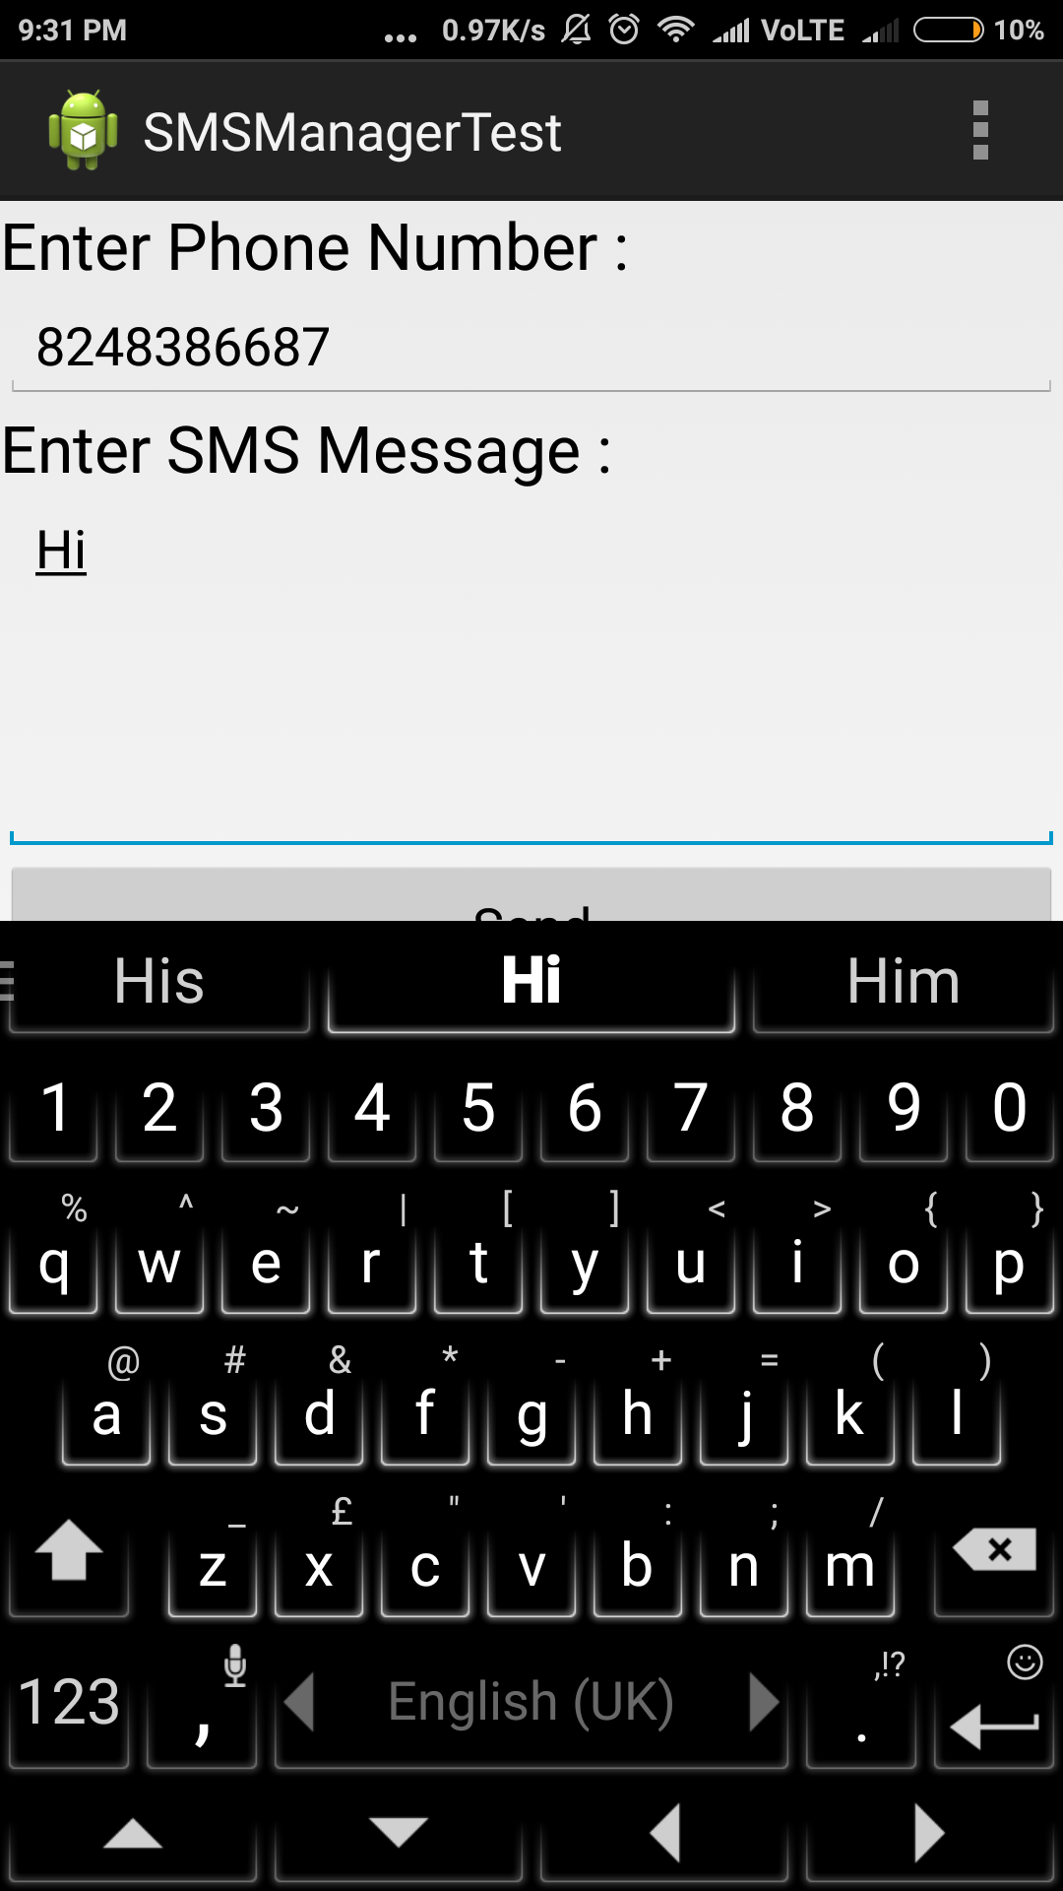

**RECEIVER:**

* Now the Receiver App will receive our message that message is now in a format of the cipher text.
* Then he enter the key that will Transform the plain text into chipper text. Once again that message is not readable for the others.

**CONCLUSION**

* This Project has given a broad confidence security to the developer and the people use software in terms of the different modules used. It also gives us an idea about the Security to which each module performs related tasks. Project also gets an idea about the interdependence of the public.

**FUTURE ENHANCEMENT**

* Now it only process for the message. In feature we added some more feature facilities like.
* Image
* Voice call
* Video calling
* Group chat
* More security throws figure print scanning and new algorithm.

**BIBLIOGRAPHY**

**References:**

* [1] Computer Science 2008, An Interim Revision of CS
* 2001(http://www.acm.org/education/curricula/ComputerScience2008.pdf)
* [2] Android Developer’s Guide. http://developer.android.com/guide/index.html
* [3] Abelson, W.F., Collins, C., Sen, R. *Unlocking Android – A Developer’s Guide*.
* Manning Pub. April 2009.
* [4] Victor Matos, Rebecca Grasser, Building Applications for the Android OS Mobile
* Platform: A Primer and Course Materials, *Journal of Computing Sciences in Colleges*,
* Volume 26 Issue 1, pp: 23-29, October 2010.